

NED UNIVERSITY OF ENGINEERING & TECHNOLOGY
Department of Computer Science & Information Technology
CS-251 Logic Design & Switching Theory

ASSIGNMENT # 01
Question 1:
- Convert each binary number to decimal:
(a)100001 (b) 100111 (c) 101010 (d) 111001 (e) 1100000 (f) 11111101 (g) 11110010 (h) 11111111
- What is the highest decimal number that can be represented by each of the following numbers of binary digits (bits)?
(a) two (b) three (c) four (d) five (e) six (f) seven (g) eight (h) nine (i) ten
- List down all possible combinations for a 5-bit binary numbers.
- iv. How many bits are required to represent the following decimal numbers?
(a) 5 (b) 10 (c) 15 (d) 20 (e) 100 (f) 120 (g) 140 (h) 160.
Question 2:
- Convert each hexadecimal number to binary and decimal:
(a) 46₁₆ (b) 54₁₆ (c) B4₁₆ (d) 1A3₁₆ (e) FA₁₆ (f) ABC₁₆ (g) ABCD₁₆
- Convert each binary number to hexadecimal:
(a) 1111 (b) 1011 (c) 11111 (d) 10101010 (e) 10101100 (f) 10111011
- Convert each octal number to decimal and binary:
(a) 14₈ (b) 53₈ (c) 67₈ (d) 174₈ (e) 635₈ (f) 254₈ (g) 2673₈ (h) 7777₈
- Convert each binary number to octal:
(a) 100 (b) 110 (c) 1100 (d) 1111 (e) 11001 (f) 11110 (g) 110011 (h) 101010 (i) 10101111
Question 3: Draw the truth table and verify the Boolean equation for the given logic diagrams.

- 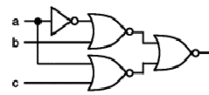

- 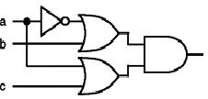
- 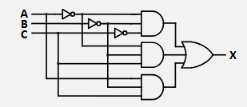
4. 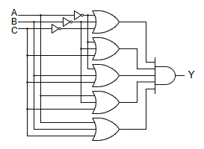

Question 4: Draw the logic diagram and truth table for the respective equations.
- F = A’BC+AB’C’+AB’C+ABC
- F = XY’+XYZ
- F = A1A2’A3(A1A3+A1A2’A3+A1A2)
- F = AB’C’+AB’C+AB(B+C’)
- F = (A+B)(A’+AB)+(B’+AB’)
- F = WXY(WX’+WY’)+WX’Y(W’X’+X’Y’)
- F = (WX+WY’)(W+X)+WX(X’+Y’)
- F=(EP+EN’)(PE’+EN’+PN’)+(PE’+EN’)(EN’+PN’)
- F = AB’+A(B+C)’+B(B+C)’
- F = [AB’(C+BD)+A’B’]C
Question 5: Draw K-Map and reduce the equation to verify.
1. F (A,B,C)=∑(0,2,3,7) = 𝐶𝐷 + 𝐴 ′𝐶′
2. F (A,B,C)=∑(0,2,4,5,6,7) = 𝐴 + 𝐶′
3. F (A,B,C)=∏(0,1,5,6)=𝐴 ′𝐵 + 𝐵𝐶 + 𝐴𝐵 ′𝐶′
4. F (A,B,C)=AC+B’C’+ABC’=A+B’C’
5. F (A,B,C,D)=∑(0,2,4,7) = 𝐴 ′𝐶 ′𝐵 ′ + 𝐴 ′𝐵 ′𝐷 ′ + 𝐴 ′𝐵𝐶𝐷
6. F (A,B,C,D)=∑(3,7,11,15) = 𝐶𝐷
7. F (A,B,C,D)=∑(1,3,5,7,11,15) = 𝐶𝐷 + 𝐴 ′𝐷′
8. F (A,B,C,D)=∑(1,3,5,7,10,11,14,15) = 𝐴 ′𝐷 + 𝐴𝐶
9. F (A,B,C,D)=∑(0,2,4,5,7,10) = 𝐴 ′𝐶 ′𝐷 ′ + 𝐴 ′𝐵𝐷 + 𝐵 ′𝐶𝐷′
10. F(A,B,C,D,E)=∑(0,1,2,3,4,5,6,7,10,19,23,25,27,29,31) = 𝐴 ′𝐵 ′ + 𝐴 ′𝐶 ′𝐷𝐸′ + 𝐴𝐵𝐸 + 𝐴𝐷𝐸/𝐵 ′𝐷

